Lab 4: Implementing Nested Procedures and Sorting

Task 1
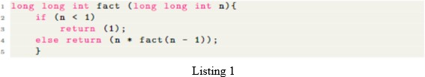
Translate the C function shown in Listing 1 into RISC-V assembly to calculate the factorial using the iterative approach. How does the stack get populated? Observe and comment on the working of code.

Code:
.text
.globl

main:
li x4, 5 # x2=n
li t0, 1
li x1, 1
loop:
ble x4, x1, end
mul t0, t0, x4 # res = res * n
addi x4, x4, -1 # n=n-1
j loop
end:
li x10, 1
add x11, t0, x0
ecall

Output
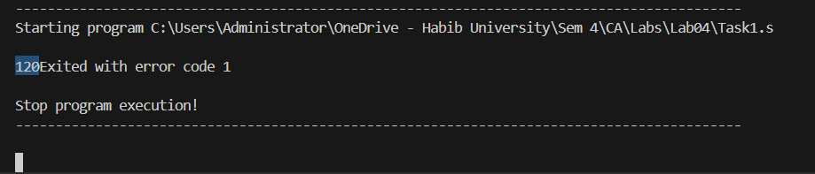

Task 2
The nth triangular number is like a factorial but instead of a product we use a summation: https:
//en.wikipedia.org/wiki/Triangular_number
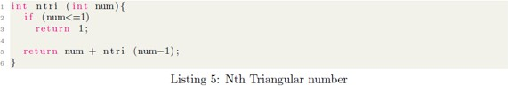

Translate the above C function to calculate the Nth Triangular number into RISC-V assembly. You should also write the wrapper code, i.e., which calls this function with an argument and then displays the result returned by this function.
Since there’s recursion going on, you will need to adjust the stack so that you store the return 4 address as well as any useful variables of the caller on the stack before calling the callee. Show the result computed. How does the stack get populated? Observe and comment on the working of code.

Code:
.text
.globl triangle

li a0, 5
triangle:
addi sp, sp, -8
sw ra, 4(sp) # save return address
sw a0, 0(sp)
beq a0, x0, base # base case: if n == 0

addi a0, a0, -1 # n = n - 1
jal triangle # recursive call

lw t0, 0(sp) # restore n
add a0, a0, t0
j done

base:
li a0, 0 # base case result

done:
lw ra, 4(sp)
addi sp, sp, 8
jr ra
j end
end:
j end

Output
stack
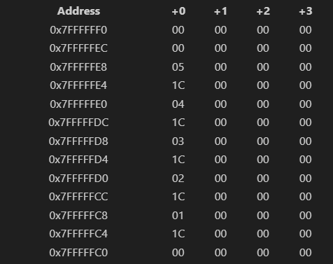
Code sums the triangle and stores value in a0
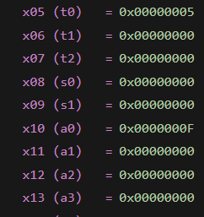
Working:
- Result Computed:
The program calculates the triangular number of 5:
$5+4+3+2+1=15$. The final result is returned in register a0.
- Stack Usage in Recursion:
Each recursive call allocates 8 bytes on the stack to save the return address (ra) and the current value of n (a0).
- Stack Population:
As recursion goes deeper (5 → 4 → 3 → 2 → 1 → 0), each call pushes its own ra and n onto the stack, creating multiple stack frames.
- Unwinding the Stack:
When the base case (n = 0) is reached, the function returns 0, and during each return, the saved n is added back to the result while the stack frame is popped.
- Correct Working of Code:
The code correctly preserves caller data across recursive calls using the stack, restores the return address properly, and implements recursion safely with a base case.

Task 3- Bubble Sort
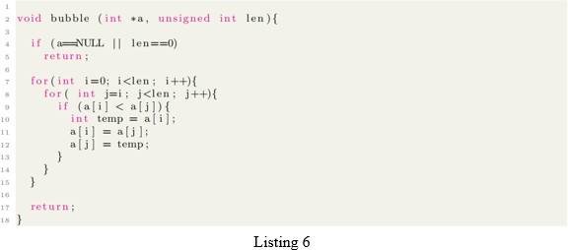

Write the equivalent RISC-V assembly code for Listing 6. a and len get passed in x10 and x11 respectively.

Code:
.data
arr: .word 7, 2, 9, 4, 1
.text
.globl main
main:
la a0, arr
li a1, 5
li t0, 0
outerloop:
bge t0, a1, done
li t1, 0
innerloop:
addi t2, a1, -1
sub t2, t2, t0
bge t1, t2, next_i
slli t3, t1, 2
add t4, a0, t3
lw t5, 0(t4)

addi t6, t4, 4
lw x6, 0(t6)

bge t5, x6, no_swap
sw x6, 0(t4)
sw t5, 0(t6)

no_swap:
addi t1, t1, 1
j innerloop
next_i:
addi t0, t0, 1
j outerloop
done:
li a7, 10
ecall

Output
Before sort
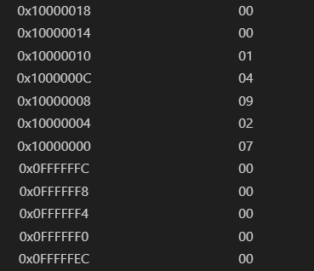
After sort
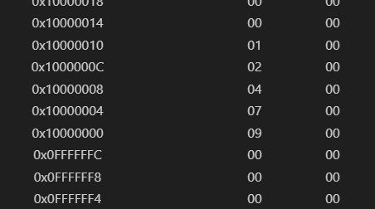

Task 4 - Student-Selected Program
In this task, students will design and implement a RISC-V assembly program of their own choice that demonstrates the concepts covered in this lab, such as nested procedures, stack management, and control
flow.
Students are encouraged to select a program that can be extended or reused in their project. Proper use of procedure calls, register conventions, and stack discipline will be assessed. Students should clearly demonstrate correct execution of the program.

CODE:
GEOMENTRIC SERIES:

.text
.globl main
main:
li x1, 7 # nth term
li x4, 1 # series starts with 1
li x3, 3 # common ratio
loop:
beq x1, x0, end # if n == 0, exit loop
addi sp, sp, -4
sw x4, 0(sp)
mul x4, x4, x3 # x4 = x4 * x3
addi x1, x1, -1
j loop
end:
j end

OUTPUT:

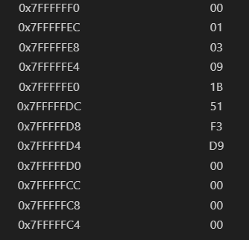

Assessment Rubric
Lab 4: Implementing Nested Procedures and Sorting

Name: | Student ID: | Section:

Points Distribution

 | Task No. | LR 2  Code | LR 5  Results
In - Lab | Task 1 | /10 | /5
In - Lab | Task 2 | /10 | /5
In - Lab | Task 3 | /15 | /10
In - Lab | Task 4 | /15 | /10
Total Points: 100 |  | /50 | /30
CLO Mapped |  | CLO 2

Affective Domain Rubric |  | Points | CLO Mapped
AR7 | Report Submission / Git Upload | /10 & /10 | CLO 2

CLO | Total Points | Points Obtained
2 | 100
Total | 100

For description of different levels of the mapped rubrics, please refer to the Lab Evaluation Assessment Rubrics and Affective Domain Assessment Rubrics provided here.

